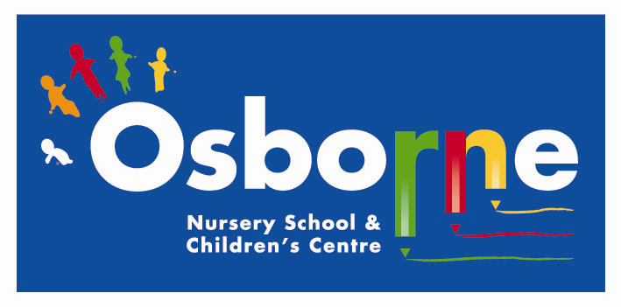

Learning through Play

Physical Development
(PD)
and keeping active

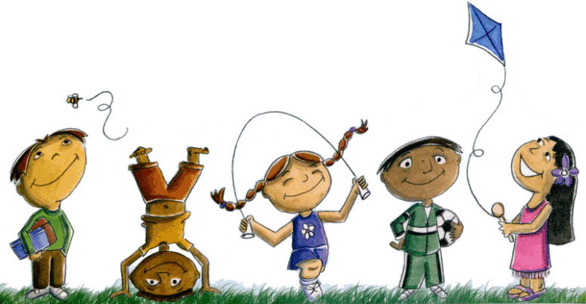



We all want our children to grow up to be happy, healthy adults. So we need to support them with making better choices for their health and well-being by teaching them good habits and routines earlier on in life.

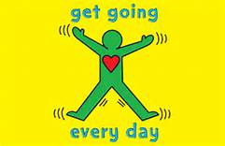
Some top tips to encourage physical tips at home:

• Play whole body action rhymes such as Heads, Shoulders, Knees and
Toes (if you don’t know this rhyme, look it up on YouTube).
• Play tennis with a balloon
• Encourage your child to help with sweeping the floor, hoovering, carrying toy boxes and shopping bags.
• Make up fun movements for your child to copy.
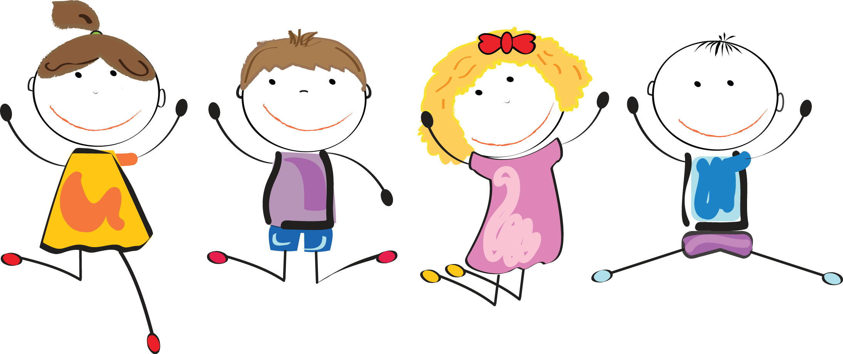
When outside, encourage your child to carry buckets of sand, gravel, adult watering cans and push a wheelbarrow.
• Play tug of war games and go on wheelbarrow walks with your child.
• Play hopping and crawling races, or dance outside with scarves and streamers.
• Play Hop Scotch and create targets to throw balls at.
• At the park, encourage your child to put their tummy on a swing seat and swing.
• Make an obstacle course to go under, over, and through using things like boxes, duvets, cushion, air beds and tables.
• Play musical bumps and musical statues.

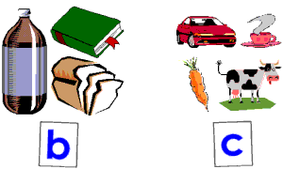
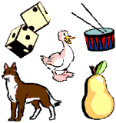
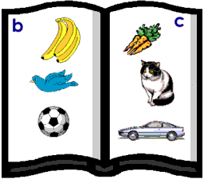
Which starts with a different
sound to the others?

.
Did you know?
The most advanced level of movement is the ability to stay completely still!

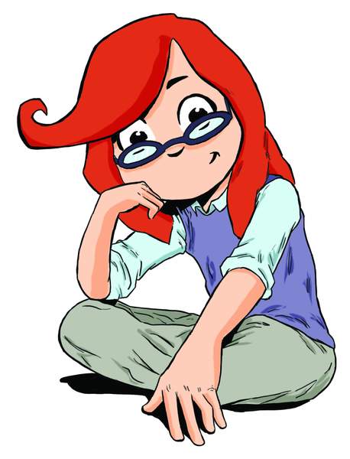

“”What I can do”
• Climb up and jump off a low object.
• Negotiate space successfully when playing chase and stop games.
• Respond to music by moving my body rhythmically.
• Catch and kick a large ball.
• Cut along a line.
• Draw horizontal and vertical lines and a circle.
• Put most of my clothes on myself.
• Use a tissue to wipe my nose.
• Wash my own hands with soap and dry them myself without help.
• Feed myself with a spoon and a fork and pour my own drink

Did you know?

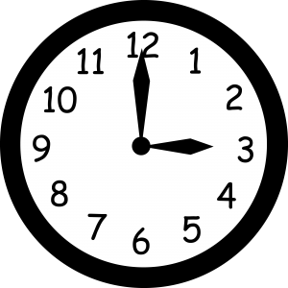

Children at 3-4 years should be active daily for at least one hour, up to three spread throughout the day.

The ‘change4life’ campaign has 8 top tips for top kids put together by health professionals you can download for free- search change4life

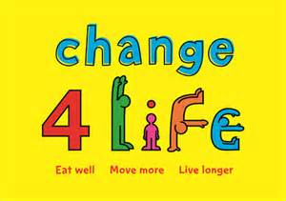
Physical Development (PD) is a prime area of learning which is broken down into 2 strands in the Early Years Foundation Stage curriculum:

Moving and handling

Health and self-care

We need to encourage children to move freely in different ways, exploring their bodies and the spaces around them.

Support their confidence by encouraging them to be independent when taking care of their own needs. Praise their efforts and celebrate their successes!

