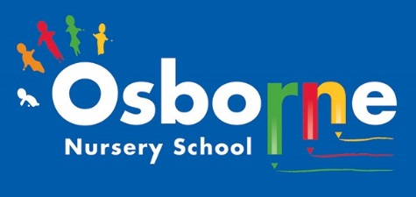**Osborne News**

**September 2024**

www. osbornenurseryschool.co.uk **0121 675 1123**

Dates for your diary:

Staff training Monday 2nd and Tuesday 3rd September 2024 – NURSERY CLOSED TO CHILDREN.

Wednesday 4th - 6th September – Home visits for our new 2 year old children.

Thursday 12th September - Stay and Play

(under 2s) every Thursday morning – 9:45 – 11:15am at OSBORNE NURSERY SCHOOL.

In October – Playdough workshops, Road safety walks and parent/ carer child progress meetings. Details to follow.

Friday 20th December 2024 – Last day of term

Monday 6th January 2024- CLOSED FOR STAFF TRAINING

Nursery News:

We would like to welcome all of our new families and welcome back our returning children too.

We’re really excited about getting to know you all. You will be given a special book to fill with photos, drawings and stories all about your family. Your Key Worker will be ready and waiting to help your child settle in and answer any questions you may have.

Our topic is called ‘Me and my Family!’ We will be creating lots of lovely learning experiences for your child, looking at their strengths and areas to develop.

Tapestry:

Those of you that are familiar with Tapestry, please continue to check for updates and photographs.

If you are new to nursery your child’s Key Worker will provide instructions to help you to access Tapestry.

Communication:

Remember to telephone us on 0121 675 1123 if your child is too ill to be at nursery.

Please check that details we have for you are correct. Let us know straight away if you have moved house or changed your phone number.

Please ring or pop into the office to report any changes.

Pleae park safely on the road and walk if you can!



Cool Kittens at Osborne Nursery. Attendance is very important at Nursery. We like to see you for all of your sessions each week. We like families to aim for attendance to be between 95 and 100%.

We monitor attendance and congratulate the Key Worker group with the best attendance each week. Watch out for the stickers and the newsletter announcement.

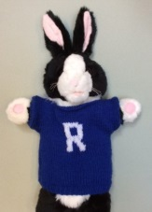

**Rights Respecting Schools Award (RRSA)**

All children have rights, no matter who they are, where they live, what language they speak, what their religion is, what they think, what they look like, if they are a boy or girl, if they have a disability, if they are rich or poor, and no matter who their parents or families are or what their parents or families believe or do. No child should be treated unfairly for any reason.

We have achieved the Silver Level of the Rights Respecting Schools Award (RRSA) and as part of this award we work with the children as well as with you to raise awareness about the UN Convention on the Rights of the Child.



Internet safety: We need to keep our children safe and help them to understand how to play games, use the internet and different devises safely. Each month we will look a t a ‘top tip’ to help with internet safety at home.

PADLOCK: Set strong passwords and set up passcode locks on all of your devises. You'll need to **create a password**to do just about everything on the Web. It might be simpler to use a short, easy-to-remember password, this can also pose **serious risks** to your online security. To protect yourself and your information, you'll want to use passwords that are **long**,**strong**,**and difficult for someone else to guess** while still keeping them relatively **easy for you to remember**.

Recommended reading this month:

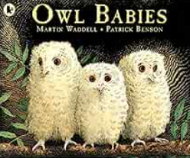

A gentle tale of three baby owls reassures young children that Mummy will always come home.

Enjoy reading this story together. Talk about the characters and their feelings. Can you relate this to your home?!

Library books will be sent home during the next few weeks. We hope that you will enjoy reading them together.

Getting ready for Nursery!

When your child comes to Nursery please send them with a change of clothes and spare underwear/ nappies. You can also send wipes if they are needed. Please place all items in a small bag and name everything! Remember we use our outdoor area in sunny weather but also cold and wet weather too. Please supply a suitable coats and footwear for the weather conditions. Please write your child’s NAME in their coats and other clothing.



Key Workers will let you know Forest School sessions will be starting.



We are now in September – when you are out and about maybe you could look for signs of Autumn? You might find different coloured leaves, shiny brown conkers on the floor or notice that the weather is changing. If you find any conkers please bring them into nursery!